Kimberly Roeten

CIS 445-01: Data Mining

October 26, 2017

Tutorial 2 Report

I encountered way more problems doing this tutorial than I did on the last one. It really didn’t help that the steps/instructions were not all numbered out, so I found myself getting lost. It was very hard to decide whether or not to just read something or figure out if it’s a step I needed to complete for the tutorial. So perhaps this is something to keep in mind for the next tutorial. In general, many of the instructions weren’t as precise as they should’ve been, or as they were in tutorial 1. Many of my examples are as follows: The instructions did not specify whether I needed to drag the HMEQ data source node to the flow diagram, then you can see the property options. The step prior to adding the interactive binning node was confusing due to the wording. Towards the end, it did not specify to click on the score node after adding the All: Home Equity Loan Scoring Data node, so trying to find the right properties was confusing at first, and the instructions were not precise on where to find the diagram ID for the SAS Code node, it took me about 4 tries then I finally realized that you couldn’t find it in the code editor window we had pulled up. Other notes I have about this tutorial is that I was unable to select the statistics button to view the skewness and kurtosis of the transform variables, but thank you for the sticky note about that. More visuals could’ve personally helped me as I am a visual learner; again thank you for the sticky notes, as I was a bit confused when we had to set the start variable number to 10 and not 14 like it had in the image; just a small note when you change the source property for the indicator variables in the impute node, it’s called missing *variables* not values; and last but not least the variable selection results I got are a little different from the sample final results in the tutorial, but it makes sense considering they were the variables selected by the node for inclusion in the preceding neural network model, which you said so yourself were a little different. On a scale of 1 to 10, the instructions were a 7, in terms of overall usefulness in getting acquainted with the software, this tutorial was an 8.

2a. 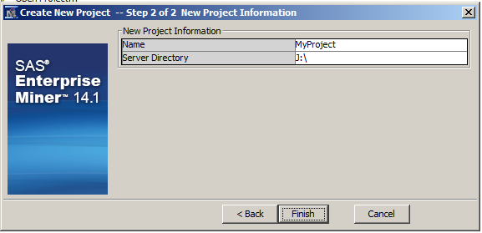

2b. 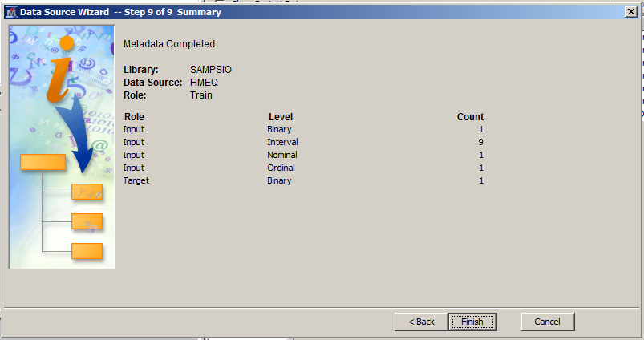

2c. 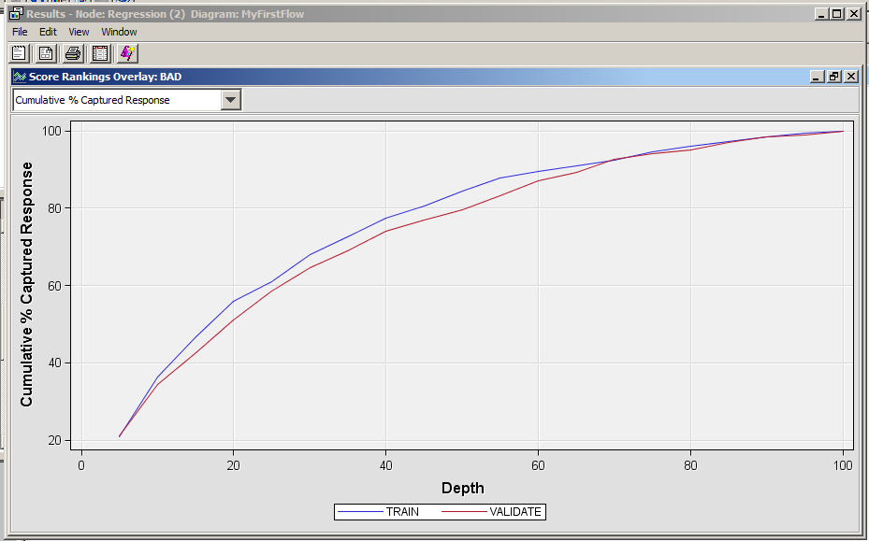

2d. 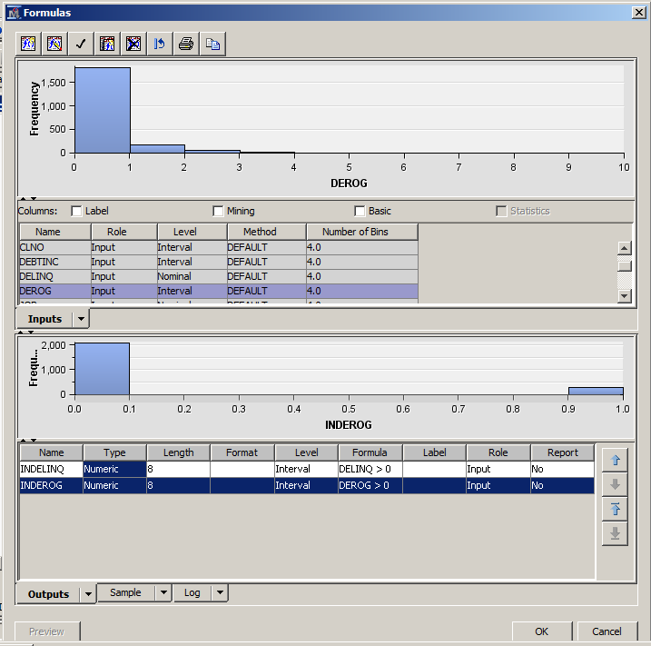

2e. 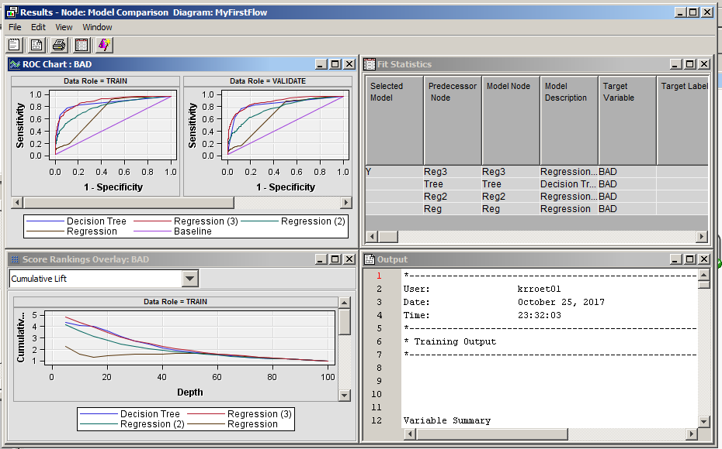

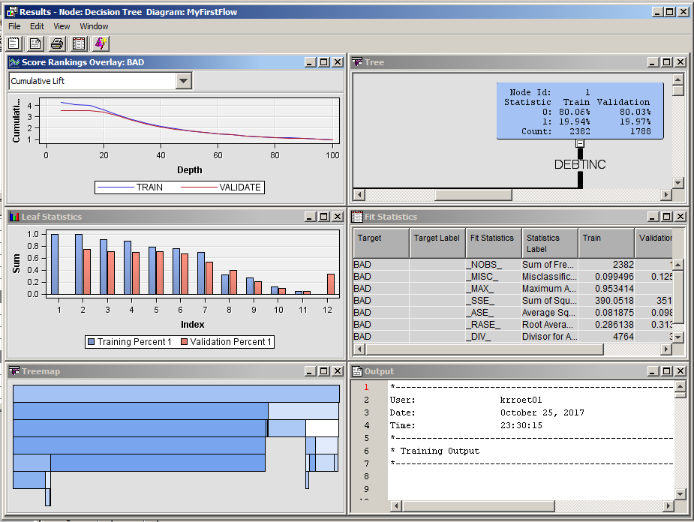

2f. 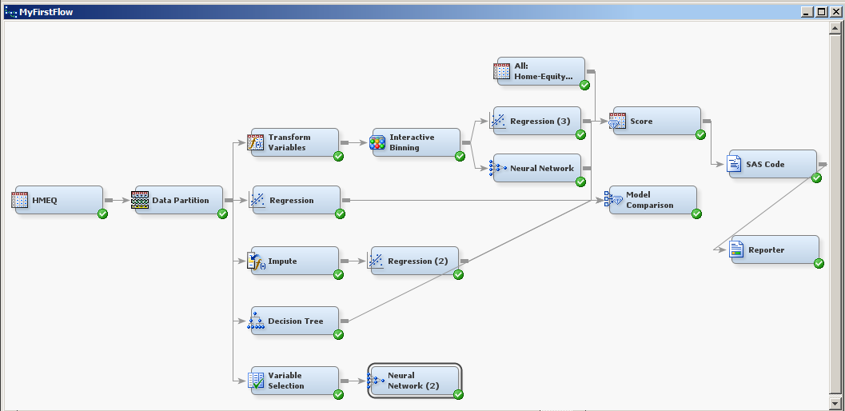

2g. 